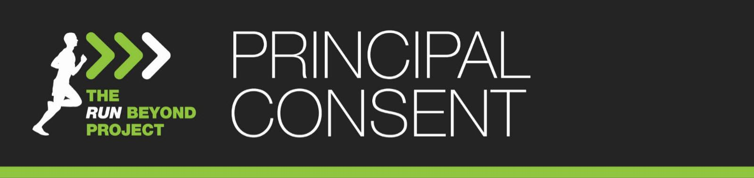

Dear Principal,
Your school is invited to participate in an experiential education program designed to develop goal-setting, commitment and resilience capabilities in students in need, using distance running as a mechanism to achieve this.
The program involves theoretical components in conjunction with practical training, and initially focuses on the development of these skills in relation to the program’s Goal Race, which will be a public fun-run event of between 10km and a half-marathon (21.1km), depending on students’ abilities. It will run either before or after school, once a week.
Throughout the course of the program, emphasis moves to the broader application of these skills beyond the finish line and beyond context of running, to other areas of participating students’ lives.
The Run Beyond Project will be implemented by at your school. We fund a day’s casual cover for this teacher to attend our Teacher Training Day, which will be in February, 2020. More details in regards to this will be supplied shortly. The project is overseen by program founder, David Criniti, an elite Australian marathon runner with a Level 1 Athletics Australia coaching accreditation.
The Run Beyond Project is a registered charity and its implementation is at no cost to participating schools and students. Participating students will be supplied with official Run Beyond Project apparel and running shoes, and have all expenses related to participation in their Goal Race covered, including meals, travel, accommodation and race entry.
Having commenced at Chester Hill High School in 2015, The Run Beyond Project has since been implemented in 12 schools, producing its 100th graduate in 2019. Please see the link below for some thoughts from our graduates as to what they’ve taken away from the program:
https://therunbeyondproject.com/wp-content/uploads/the_run_beyond_project_in_your_school.pdf

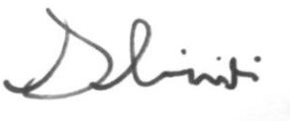
Permission Notes and Risk Assessments will be developed for approval as required. Sincerely,

David Criniti
Founder – The Run Beyond Project davidcriniti@therunbeyondproject.com 0411 438 344

THE RUN BEYOND PROJECT PRINCIPAL CONSENT FORM
I, (print name) give my consent for my school,
to participate in The Run Beyond Project, 2020. Signature:
Date:

