The Run Beyond Project develops goal-setting, commitment and resilience in high school students in need. Students participate in theoretical sessions in support of a physical training program, enabling them to work towards a goal-race of up to a half-marathon in distance. The program develops students’ understanding of how these skills can help them, beyond their target event, and beyond the context of running, to enrich all areas of their lives.

Introduction………………………………………………………………………………………………………………………………….. | 2
The Approval Process…………………………………………………………………………………………………………………….. | 3
The Implementation Process………………………………………………………………………………………………………... | 4
Health and Safety……………………………...………………………………………………………………………………………….. | 5
The Run Beyond Project in Your School…..…………………………………………………………………..………………… | 10
Social Media……………………………………...…..……………………………………………………………………………………… | 13
Other Media……………………………………..……...…..……………………………………………………………………………… | 15
Recruiting Students……………………………………………………………………………………………………………………….. | 16
Delivering The Run Beyond Project to Students…………………………………………………………………………….. | 17
Practical Component Delivery………..……………………………………………………………………………………………... | 19
Theoretical Component Delivery……….………………………………………………………………………………………….. | 22
The Goal Race……………………………………………………………………………………………………………………………….. | 23
Graduation…………………………………………………………………………………………………………………………………….. | 25
Leadership Program………………………………………………………………………………………………………………………. | 26
Belonging to Run Beyond...And Beyond………………………………………………………………..………………………. | 27
Curriculum Resources………………………………………………………………………………..………………………………….. | 29

The Run Beyond Project uses running as a mechanism to develop goal-setting, commitment and resilience skills within high school students in need.
The program was founded by David Criniti in 2015 at Chester Hill High School, with the initial cohort travelling to Hobart to complete the Cadbury Marathon’s half-marathon event on January 10, 2016.
It has since expanded to a multi-school project which is administered centrally and implemented locally by teachers at participating schools.
On 2 September, 2016, The Run Beyond Project was registered as a public company, limited by guarantee. We were granted Deductible Gift Recipient status by the Australian Charities and Not-For-Profit Commission commencing from this time.
Before commencing, schools are required to complete the approval process outlined below. Once approved by The Run Beyond Project board, the program is implemented by designated teachers. The program involves theoretical components which focus on our core outcomes related to goal-setting, commitment and resilience, as well as practical training sessions. A pre-test is completed by students before the commencement of the program, and a post-test and evaluation at its conclusion.
Typically we request teachers to administer the program either before or after school hours. This may vary depending on school context.
The program involves the selection of a Goal Race which is designed to be challenging yet achievable and safe for all students. This race will be approved by The Run Beyond Project board as part of the school approval process. It is not essential that all students complete goal-races of the same distance, though it is strongly encouraged that the goal-races of all students occur at the same event. (For example, The Sydney Running Festival may be a goal event for a school’s program, with some students running the 10km event, and others completing the half marathon).

Before starting The Run Beyond Project program, the official approval process must be completed. This is designed to maximise the impact on the students who will most benefit. Teachers are encouraged to contact The Run Beyond Project (contact@therunbeyondproject.com) before commencing the approval process for an informal discussion.

The approval process has four stages:

(i) Initial contact and informal discussion with The Run Beyond Project Team. During this discussion, the parameters of the project will be explained, and prospective teachers will have the chance to discuss the specific needs of their school.
(ii) Principal Consent form submission. This involves support from your school’s principal.
Contact us for a copy of the form at contact@therunbeyondproject.com
(iii) Submission of prospective students. Students involved must fall within The Run Beyond Project’s selection policy and criteria. The selection policy and criteria can be viewed at www.therunbeyondproject.com/forms/run_beyond_student_selection_policy.pdf
The submission of students can be done via this excel form:
http://therunbeyondproject.com/forms/proposed_student_staff_details.xlsx
(iv) Approval by The Run Beyond Project team. The Run Beyond Team will ensure that students meet the set criteria, and will make contact to ensure a suitable goal-race can be negotiated. This typically occurs within a week of submission of prospective students.

This section provides a brief overview of the stages of the implementation process. Later sections in this booklet provide more information about the specifics of the teacher role in delivering the program.

(a) – Dissemination and collection of permission notes. The Run Beyond Project must be completed in accordance with all relevant school and department policies. All necessary paperwork, including permission notes, variation to routine forms, and risk assessments must be completed in order for this to proceed. The Run Beyond Project board can provide assistance with the development and completion of these forms when required.

Students and guardians are asked to complete a Permission to Publish form, provided by The Run Beyond Project board. This provides us with consent to use images on social and traditional media. Teachers return completed forms to the board and notify us of forms not returned. Students may participate in the program without granting permission to publish, but cannot have their image published in any media.

Student Contracts, provided by The Run Beyond Project Board, must be completed in order for students to commence participation in The Run Beyond Project.

(b) – Student pre-tests. These tests - provided by The Run Beyond Project board - are administered, in conjunction with post-tests upon the completion of the project, in order to analyse the effectiveness of the project. Completed tests are returned to The Run Beyond Project board.

(c) – Program implementation, supported by The Run Beyond Project board. The board provides support and advice prior to and throughout the implementation of the program. Questions can be directed to contact@therunbeyondproject at any time.

(d) – Goal Race completion. The Goal Race, as with the program itself, must be completed in accordance with all relevant school and department policies. All necessary paperwork, including permission notes, variation to routine forms, and risk assessments must be completed in order for this to proceed. The Run Beyond Project board can provide assistance with the development and completion of these forms when required.

(e) – Student post-tests and evaluation forms. Post-tests and evaluation forms are provided by The Run Beyond Project board. These are returned to the board upon completion.

(f) – Graduation. The Run Beyond Project board provides Graduation Certificates for participants who have successfully completed the program. Teachers are encouraged to present these certificates in a public arena, such as a school assembly, in order to appropriately celebrate the achievements of these students.

(g) – Program evaluation. The Run Beyond Project is constantly aiming to improve the experience for our students and teachers. We ask teachers to provide us with feedback at any time throughout the program. Formal evaluations are completed at the completion of the program as a formal conclusion.

The Run Beyond Project encourages students to progress towards the safe and healthy completion of their Goal Race. We have a number of mechanisms in place to minimise the risk of injury to participants:
- The selection of events being done in consultation with accredited coaches, in order to be challenging but achievable and safe for all participants.
- Allowing adaptations to programs in response to a range of factors including overestimation of students’ capabilities.
- Students and parents / guardians are required to complete a consent form prior to student acceptance into the program, outlining any factors which may inhibit the safe completion of the program.
- The program is developed in consultation with, and overseen by experienced runners and accredited coaches on The Run Beyond Project board.
As with any physical endeavour, injuries can occur which impact to various degrees on students’ abilities to continue to safely participate.
The Run Beyond Project endeavours have any injuries treated as effectively as possible in order to:
- minimise harm
- prevent further injury
- return students to normal functioning as soon as possible.
- allow continuation in and completion of the program where possible.
HS1 - Working With Children Checks.

It is a requirement of admission into the program that all volunteers’ details be submitted to The Run Beyond Project board.

A Working With Children Check approval number and expiry date is required to be submitted to The Run Beyond Project.

HS2 - Injury prevention principles

We aim to provide appropriate challenges for students which are suitable for their age and skill level. The following points outline a strategy designed to minimise the risk of injury to participating students.

HS2.1 Pre-program.
Students must complete an Expression of Interest Form which includes disclosure of any pre-existing conditions or factors which may compromise their ability to safely complete this program. This form must be signed by a legal parent or guardian.

If any pre-existing conditions or factors are listed, an official Medical Certificate required before a student is admitted to the program.

HS2.2 Training program development.
Each school’s training program will be tailored to the needs and abilities of the participating students, and will be designed to adequately to prepare these students for their goal event.
The Run Beyond Project board will provide assistance with the development of the program and approval is required before commencement.

HS2.3 Program adaptation.

Programs may be adapted at various times for a number of reasons to minimise risk of injury. The program is designed to provide a challenging but realistic goal for students. Factors that may lead to revision of programs are over-estimation of students’ physical capabilities, unforeseen circumstances impacting on training schedules, cancellation of goal events, among others.

The Run Beyond Project board will assist with the adaptation of programs to suit changing circumstances.

HS2.4 Warm up
All physical sessions should commence with an appropriate warm up and cool down.
Warm ups are generally considered to serve numerous functions:
- Physical preparation for the training session.
- Mental preparation for the training session.
- Injury prevention.
- Performance enhancement

Additionally, within the context of The Run Beyond Project, warm up time provides:
- Opportunities for group discussion of concepts taught in the theoretical side of the program.
- Opportunities for leadership moments by providing students with the chance to lead parts of the warm up. This should only be done once students are familiar with appropriate warm up principles.

Professor Ian Jeffreys suggests warm ups be categorised into a 3 phrase RAMP process.
1 - Raise
2 - Activate and mobilise
3 - Potentiate or Performance.

Phase 1 - Activities to raise body temperature, heart rate and blood flow can include:
- Sprint technique drills such as A-skips and B-skips
( https://www.youtube.com/watch?v=PcWsOM144xo )
- Planned change of direction drills, such as running set routes around cones.

Phase 2 - Activities to activate key muscle groups and mobiles key joints and ranges of motion used when running.
Activities could include:
- Glute bridges
- Lunges
- Side-step-squats

Phase 3 - Activities designed to lead to performance enhancements in the session.

These most likely include ‘strides’ or, faster run throughs of 50-100m which prepare the body for running at a faster pace.

HS2.5 – Training

Environmental conditions
Training in hot conditions
● An assessment of the apparent temperature should be made prior to commencing training in hot weather and a decision made to proceed, modify or cancel training accordingly.
○ This should take into account the relative experience and conditioning of the participants
○ Conditions should continue to be monitored throughout the session and the decision altered if indicated.
● Confirm pre-session hydration with all participants as per normal hydration guidelines (below)
● Current school policy on exposure to sun is sufficient for running training and should be enforced for all participants
○ Be aware of the effect of additional protective clothing on skin surface temperatures. Use of long tights should be discouraged in hot conditions
● In hot conditions, any periods of intense effort should be shortened or the level of effort reduced. Regular drinks breaks should also be provided.
○ Note that after any drink break of more than 5 minutes, a short warm up should be undertaken prior to recommencing training.
Training in cold
● Training in cold weather requires a longer initial warm up as well as additional warm ups throughout the session after any period of rest greater than 5 minutes
● Participants should be encouraged to dress appropriately as well as given ample opportunities to add or remove clothing during the session (eg. jackets in warm up, removed for high intensity work and put back on for cool down phase)
● The effect of cold is increased in wet conditions. This must be taken into account with warm up duration and additional warm ups throughout the session as well as the clothing selection - note that waterproof jackets may retain significant amounts of heat and leave participants susceptible to hyperthermia, even in cold conditions.
● Younger and/or lean children are more susceptible to cold and should be monitored closely throughout sessions in cold conditions

Hydration and nutrition
● Ensure participants are well hydrated leading into sessions
○ ACTION: Prior to every session, ask participants “When/what/how much did you drink last?”
● If sessions are longer than 60 minutes or in hot conditions, plan for drink breaks
● Simple recovery techniques can include:
● Drinking a variety of fluids straight after training
● Eating plenty of carbohydrate-rich foods immediately after training
● An active warm down with minimal resistance
● A good night’s sleep
Musculoskeletal injury
Acute injury
This is characterised by a sudden onset of symptoms, with or without a known incident.
If there is:
● Immediate swelling
● Deformity - visible difference to other side
● Inability to move or weight-bear
○ Unable to move their own limb (ie. unassisted)
○ Unable to walk 5 steps (regardless of pain)
ACTION: Commence first aid and/or RICE. Do not put load through limb and seek immediate medical assessment
If the above points are not present but there is:
● Swelling within 1hr
● Bruising at site of injury or elsewhere
ACTION: Commence RICE. Cease training and seek medical assessment within 72 hours
Insidious injury
This is characterised by a gradual onset of symptoms, typically without a known incident.
If there is:
● Pain
○ One-sided/asymmetrical
○ Worsening
○ Constant
● Any visible swelling
● Stiffness
○ Soon after training
○ Next morning for >30min
ACTION: Cease training and seek medical assessment within one week

Over-training indicators
● Increased perceived exertion at similar similar running pace
● Sudden decline in running performance
● General unexplained fatigue
● Reports of waking up feeling tired or exhausted
○ ACTION: On a weekly basis, ask participants “How long did it take for you to feel recovered or back to normal after the last session?”
● If heart rate monitoring is available, look for a sudden drop in max HR during high intensity efforts (NB. Wrist-based HR monitors such as Apple watches are not as accurate as chest strap monitors and should not be relied on for assessments of over-training)
● ACTION: If over-training is suspected, training should cease and medical assessment is recommended
○ Note: a period of rest from training may not be sufficient to rectify this situation so medical assessment is recommended in all cases
HS2.6 - Cool down
An effective cool down post-session has the effect of gradually returning the heart-rate and blood flow to regular levels. Cool downs often comprise of a few minutes of walking or jogging at a pace significantly slower than workout pace, followed by static stretching of major muscle groups used in the activity (calves, hamstrings, quadriceps and glutes).

Foam rollers are also often recommended for cool down routines.

It is imperative for the success of The Run Beyond Project that we maintain a positive relationship with the schools in which we are operating.

We are committed to working with the schools implementing our program to develop each student toward goals that will have lasting implications. From enquiry stage through to implementation and evaluation, The Run Beyond Project provides support and authorisation to schools as they move through the agreed approval and implementation process indicated in 2(a) and 2(b) above.

The Run Beyond Project Provisions.

The Run Beyond Project provides each participating school with the following:
- Program templates and curriculum resources which promote the development of goal-setting, commitment and resilience skills in participating students as they work towards the completion of a Goal Race.
- Ongoing support to adapt the program to suit your school’s students.
- Free Athletics Australia Level 1 Community Coaching Certificate for the Cohort Teacher.
- Free professionally fitted shoes for participating students.
- Free official The Run Beyond Project singlet for each participating student and Cohort Teacher.
- Free official The Run Beyond Project t-shirt for each participating student and Cohort Teacher.
- Free entry to approved Goal Race for each participating student and Cohort Teacher.
- Graduation Certificate to all participating students who complete the program requirements.

Additionally, we will endeavour to supply students and staff with the following when circumstances permit:
- Equipment to assist in the injury prevention and management process, including foam rollers and spikey balls.
- Post-diagnosis physiotherapist advice on the management of injuries.
- Entry to additional races which serve as interim goals as students progress towards their Goal Race.
- Apparel from our sponsors and partners.

The Run Beyond Project General Implementation Requirements.

The Run Beyond Project is implemented locally by teachers who are passionate about ensuring their students develop key capacities to enable the achievement of potential. In most cases, but not always, teachers are also keen runners, whether elite or back-of-the-pack.

Teacher Mentor Role
The Run Beyond Project is delivered within each school, by a teacher mentor / teacher mentors, to their approved cohort. They are supported by The Run Beyond Project board in this process, and can make contact at any time for assistance at contact@therunbeyondproject.com

Excursion notices / permission notes, risk assessments and other administrative requirements.
The program should be delivered in accordance with school and relevant department policies, which includes the completion of necessary administrative requirements including excursion notices / permission notes, risk assessments and other administrative requirements.

A bank of templates and existing paperwork is available, which teachers are encouraged to use as a basis for their administrative requirements in order to minimise unnecessary duplication of resources. Please contact for access to these resources at contact@therunbeyondproject.com

Flexibility of program delivery

The program is designed to promote key capabilities to students with diverse needs in a range of settings. To effectively achieve this, flexibility is paramount. In terms of curriculum materials, physical training requirements, program duration and goal events, the Run Beyond Project team has developed the following materials:

(a) Curriculum materials
A number of curriculum materials are provided which aim to develop student capacities in the core areas of goal-setting, commitment and resilience. Throughout the course of the program, it is expected that a teacher will implement one session on each of these three core areas.

Teachers are encouraged to contact The Run Beyond Project board for assistance in modifying materials that are deemed inappropriate for their student cohort.

This flexibility is designed to ensure that the core values of the program can be implemented in a manner suited to the individual circumstances of each participating school; the teacher mentor, and the students.

(b) Physical training requirements:
Physical training will be dependant on a number of factors, including participants’ age, year group, previous running experience, medical conditions, physical capabilities, impairments and the goal-event targeted.
Typically, one physical training session per week is required. Students may be directed to complete runs in their own time in between official training sessions.
Training schedules will be overseen and supervised by The Run Beyond Project directors who are accredited coaches.
Teachers are encouraged to contact staff at The Run Beyond Project whenever questions arise.

(c) Program duration:
10km: Goal-events of 10km or less require a program of no less than 1 term in duration (10 weeks minimum)
21.1km: Goal-events of 21.1km, require a program of no less than 2 terms in duration (20 weeks minimum)
Other: Goal-events in between these distances require a program between 10 and 20 weeks, to be negotiated with The Run Beyond Project directors, but typically requiring approximately 1 week per km of race distance.

(d) Goal Races:
Goal events will be decided upon in consultation between The Run Beyond Project board and the school.

Participating students and teachers will have their entry to the event covered by The Run Beyond Project. The Run Beyond Project may also cover travel and accommodation expenses where appropriate.

Social media is used by The Run Beyond Project to acknowledge the progress and achievements of our students; to demonstrate appreciation for the support of our sponsors, without which The Project is not sustainable; and to promote awareness of our organisation.
We strongly encourage participating teachers to interact appropriately with The Run Beyond Project on social media to assist in the achievement of these aims.
Our major social media channels are:
Facebook:
www.facebook.com/therunbeyondproject

Instagram:
@therunbeyondproject

Permission to Publish
Part of the Approval Process involves providing prospective students with Permission to Publish forms. Please ensure that when parental / guardian Permission to Publish has not been granted via these forms, images of the relevant students are not published or provided to our Social Media Team for publication.
Providing Images for Publication
Teachers are asked, where possible, to provide weekly updates for us to post on social media. These can be emailed to socialmedia@therunbeyondproject.com or sent via SMS / MMS to the number provided to you upon commencement of the project.
How to interact with The Run Beyond Project on Social Media.
In addition to supplying our Social Media Team with weekly training updates, you can help the project’s exposure by:
- Encouraging your school to post updates of your cohort’s progress.
- Tagging us @the run beyond project on Facebook and @therunbeyondproject on Instagram.
- Sharing our social media posts via your personal and /or school’s pages.
- Engaging with our social media posts with comments and ‘likes’.

The project is about community building, so please engage with posts of other schools in The Project to facilitate this process. Engaging with other schools’ posts builds a sense of belonging to The Run Beyond Project team and helps to establish our identity within the local running community. Positive engagement which acknowledges student achievements, therefore, acknowledges these as more than individual efforts, but as contributions to the running community as representatives of their schools and of The Run Beyond Project.

The Run Beyond Project and Traditional Media
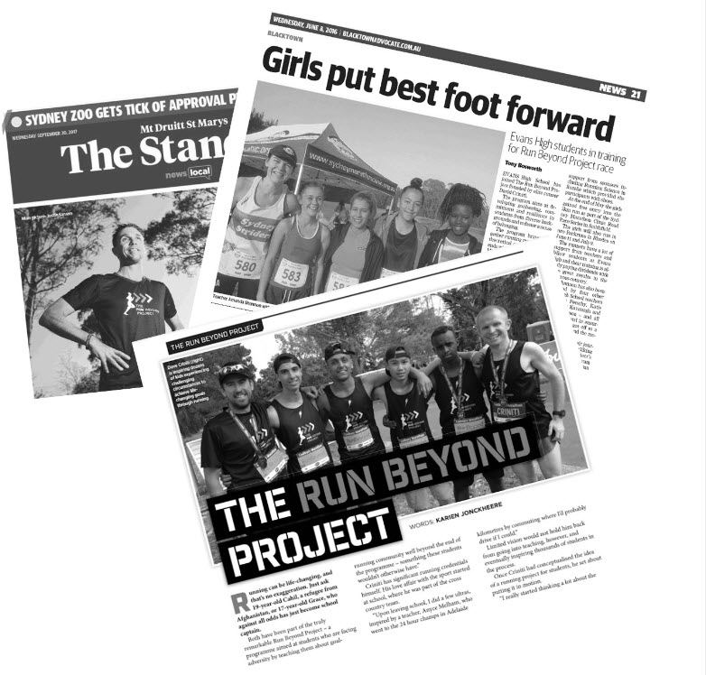
At various times, we may pursue or be requested to participate in interviews and other media-related activities in order to promote The Run Beyond Project.
Your participation in these activities when requested is of benefit to The Project and is greatly appreciated.
All interviews and media related activity must be authorised by our directors prior to their conduction. If you are approached by any media outlet for such purposes, or have a proposal for media-related activity, please contact us on contact@therunbeyondproject.com to discuss.

As a charitable organisation, registered with the Australian Charities and Not-For-Profits Commission, it is imperative that students meet the criteria set out in our Student Selection Policy.
http://therunbeyondproject.com/forms/student_selection_policy.pdf

With this in mind, recruiting via whole school announcements at assemblies, in newsletters and on school social media pages is not recommended.

A more effective approach is the identification a pool of possible candidates who meet the criteria based on discussions with teachers, Year Advisors counsellors and Welfare Team Members.

Prior to discussions with students, advise The Run Beyond Project board of potential candidates to ensure eligibility requirements are met.

Initial discussions with students should emphasise the fun, supportive nature of the project, the exciting sense of challenge and adventure involved, and the rewarding elements associated with the achievement of a significant goal.

First of all, thank you. The Run Beyond Project exists to facilitate the development of important life skills within our students; to empower them to take on the world. And this simply cannot be done without your support.

Our students are in need of our support. While many programs of a nature similar to ours are delivered by external agencies, The Run Beyond Project has deliberately avoided this model in order to adhere to a model which allows the program to be delivered by teachers themselves.
The rationale for this is that by using teachers who have an existing relationship with students, we are in the best position to provide a safe and trusting environment that fosters a sense of attachment which best allows for the development of responsibility and skills.

This STARS model of wellbeing was developed by UNICF in 1991 and is a key theoretical framework which underpins our program. Let us elaborate on the key terms in the paragraph above which comprise the STARS model:
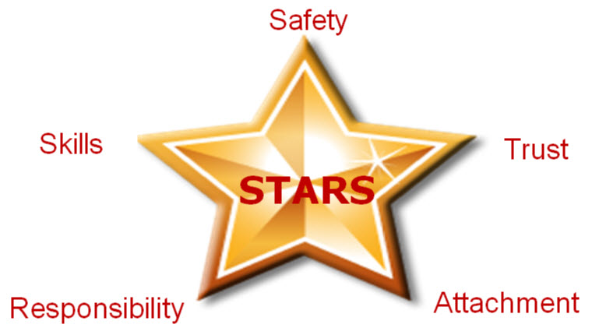
Safety: Many of our students lack safety in their lives or have done so in their recent past. Teachers can facilitate a safe, secure and structured environment which is a haven for all students, particularly those who have experienced trauma. Consistency and clarity of rules and consequences is a simple way to promote this.

Trust: Teachers are in a key position to model behaviours and relationships that promote trust, a behaviour that is often difficult to exhibit for those who have been impacted by trauma. Reliability, predictability, fairness, kindness, understanding and interest in students help to promote the development of trust, as does the avoidance of aggressive behaviours.

Attachment: The building of trust promotes connections, a sense of being valued and accepted and belonging. We have a number of mechanisms in place to promote attachment and belonging, including the provision of Run Beyond attire, the use of social media to promote and celebrate achievements within the context of our team environment. Teachers are encouraged emphasise the team-oriented nature of all Run Beyond activities in order to promote and development attachment and belonging.

Responsibility: Trauma is often linked with limited control over life choices and powerlessness. We are in a position to provide students with opportunities to make decisions which allow them to take responsibility. As with many aspects of The Run Beyond Project, this can be done in small increments at first, relating to aspects of training such as which course to run, who will lead the warm up, deciding on goals for the session and as the students moving towards the Goal Race. More importantly though, the greater impact will be when considerations are expanded beyond the concept of running. Goal-setting, commitment and resilience activities and discussions are a great way to initiate discussions about decisions that require students to think about responsibility.

Skills: We work with students who have missed out on learning opportunities. The first steps in the STARS model build their capacity to do that. As we work through the Run Beyond Project, we encourage a sense of belonging in an environment that is safe and built on trust. We provide opportunities throughout the program for students to experience success as they see themselves progressing from week to week. In conjunction with this, we develop - through constant discussions around our key concepts of goal-setting, commitment and resilience - a sense of responsibility required to develop skills. It is imperative that we consistently remind students of implementing the skills they learn beyond the concept of running.

The STARS model underpins our work throughout all aspects of the program. The following sections provide more detail on considerations when delivering the practical and theoretical components of the curriculum.

Practical Sessions Work in Conjunction with Theoretical Components
A fact mentioned numerous times in this document, and one which we ask you, as a teacher, to make abundantly clear to our students, is that we are not a running club. We hope that this project fosters an appreciation, and even a passion for leading an active lifestyle, and for running in particular, but that is not our primary purpose.

Our purpose is to use our physical sessions, in conjunction with the theoretical components, to develop life skills which students can apply beyond the context of running, with a focus on goal-setting, commitment and resilience.

Goal-setting, Commitment and Resilience in Practice
With the aforementioned purpose in mind, it is recommended that sessions be used as an opportunity for teachers to familiarise students with the concepts of goal-setting, commitment and resilience. This can be done in numerous ways, such as:
- Making students aware of the goal for the session, and where the session sits in terms of the program’s culminating goal-event. Eg: “Our goal is to run 4km without stopping today. Remember, our goal-event is 10km, so when we complete today’s goal, what percentage of our goal-distance have we achieved?”
- Congratulating students on the commitment they’ve demonstrated in attending each session, and discussion the benefits of that commitment and how it is helping them progress towards their goal. Eg: “It’s great to see the progress we’re making with our commitment. Remember 4 weeks ago when we were struggling to run 3km without stopping.
- Reminding students of the importance of resilience in achieving their goals. Eg: “It’s been great to see some of the resilience demonstrated over the past few weeks. Some of us were struggling with the distance, some of us were struggling with the heat. Some of us were struggling with stitches. But we haven’t given up in the face of these hurdles. We’ve worked on strategies to overcome them such as pacing ourselves better, ensuring we’re better hydrated and have eaten more sensibly before training.”

Beyond Running
Brining our key concepts of goal-setting, commitment and resilience into discussions throughout physical sessions is an important part of the project. Explicitly outlining how these skills relate to participation in the project and the goal-event is essential. From this starting point, it is also important to facilitate discussions, where appropriate, around the application of these skills in broader contexts relevant to students’ lives, beyond the context of running.

Safety First
The safety of our students and teacher volunteers is our number 1 priority. Goal-events are negotiated between Cohort Teachers and The Board with this in mind. Programs are designed with this in mind. Prior to commencement of the program, teachers must ensure that any documentation required by their school and any relevant governing bodies, such as Risk Assessments and Variation to Routine forms, have also been completed and approved.
Each session should commence with a warm up to ensure that students are adequately prepared, mentally and physically, to undertake the day’s session. See the Injury Management Policy for more information on this.
The warm up provides an opportunity for brief discussions in which session goals can be outlined and students can be instructed to raise any concerns with their ability to complete the session.
Also ensure that students are adequately hydrated and have adequate sun protection to complete the session safely.

Gradual Progression
The goal-event, to be negotiated with The Run Beyond Project board, is designed to be challenging but achievable for all participants, and is selected with participant safety, wellbeing and enjoyment in mind.
In most cases the goal for students is simply the completion of a final event, with the focus being on making the distance rather than obtaining a specific time. With this in mind, physical sessions often involve an approach structured around the gradual progression towards the completion of that distance, with a greater focus on endurance than intensity.
The largest distance completed in training is usually approximately 20-25% less than the Goal Race distance. This leaves an element of the unknown for race day, designed to enhance the significance and sense of achievement associated with the goal event, while at the same time ensuring that the students are well enough prepared that race day does not pose a challenge for which they are ill-prepared.
With that in mind, a weekly training program, designed to prepare students for a 10km Goal Race, in terms of kilometres, may look like the following.

Sample 10 Week Program Weekly Training Session Kilometre Totals
Week | Kilometres
Week 1 | 3
Week 2 | 3
Week 3 | 4
Week 4 | 4
Week 5 | 5
Week 6 | 5
Week 7 | 6
Week 8 | 7
Week 9 | 7.5
Week 10 | 5
Of course, there is no one set program for achieving this result. The outline above allows for a steady build up for students who are novice runners, and provides time for adaptation, especially in the earlier weeks when they have had little to no experience with running.
Towards the end there is a more steady increase, but at this stage the increase in kilometres each week represents a smaller increase in percentage terms than earlier in the program.
The final week in the above outline also provides for a ‘taper’ week before the goal event, assuming it immediately precedes week 10’s training session.

Taper
As per the outline and comments above, a ‘taper’ should precede the goal event, such that students are not completing their longest session in the last few days prior to the event. Rather, this session is usually completed 2-3 weeks prior to the goal-race. The taper ensures that the students arrive at the startline on race day in good physical condition and not unduly fatigued.

Training At Home
Students should often be tasked with sessions to be completed on their own, between official school training sessions. This is a great talking-point in relation to commitment at the beginning of a session. Eg: “How did everyone’s home training sessions go this week? Tell us about them.” There may often be occasions where students have not completed assigned sessions at home. Responses to this should be framed positively rather than punatively, with reference to questions about the Goal Race and what commitment is needed, moving forward, in order to achieve the goal.
Sessions to be completed at home should always be less than the longest distance completed as part of a group training session and which students should be able to complete in relative comfort.

Concerns with Training Load
Contact The Run Beyond Project board immediately if you feel that students are finding the training load taxing to the extent that it is limiting their enjoyment, risking injury or causing them to re-consider their involvement in the program. Student safety is our number one priority. In cases where it is suspected that a student may be injured, please refer to our injury management policy.

Program Variations and Support
Programs may need to be varied for a number of reasons, including weather, student or staff absences, cancellation of Goal Races among other reasons. We will work with you to support the implementation of variations when required. Contact us as soon as possible after it becomes apparent that variations are required.
Our role is to support the implementation of the project and we can be contacted at any time to discuss concerns as they arise.

The final section of this handbook includes a teacher version of the student handbook, with a series of teaching points for each activity.

Additionally, this section contains some general advice to keep in mind throughout the program in its entirety, in addition to the overarching STARS model outlined previously. This advice will help facilitate the effective teaching of the program’s theoretical and practical components.

More Than a Running Club
Most importantly, it is imperative to keep in mind at all times, and to consistently emphasise to students that The Run Beyond Project is not a running club. The Project is focused on student welfare and life-skill development, with any improvements in physical fitness being a byproduct of this. Run Beyond uses running as a mechanism through which we develop goal-setting, commitment and resilience, foster a sense of belonging and build confidence.

Going Beyond
The word ‘beyond’ is integral to our philosophy. While we develop these skills within the context of preparing for a goal-race, teachers are reminded to consistently emphasise the importance of the application of these skills beyond the context of running. The curriculum resources are designed to promote the broader application of these skills, and teachers are encouraged to support this development by linking these concepts to discussions in training sessions and other Run Beyond activities, where appropriate.

For example, students may be having an incidental discussion about wanting a part-time job. This is a great opportunity to discuss the concepts promoted through Run Beyond.
- Goal-setting relates to goals around getting a CV and cover letter written, getting a job, and using the job as a means to save for a variety of purposes.
- Commitment relates to the qualities required to perform well within the workplace as well as managing other obligations and aspects of life.
- Resilience relates to continuing to apply for work in the face of unsuccessful attempts, and the ability to use feedback to improve at each successive attempt.

The Goal Race is an integral part of The Run Beyond Project. It is the centrepiece event around which the implementation of the project is structured.

As is mentioned elsewhere in this document, the goal-race is negotiated with The Run Beyond Project board before commencement of the program at your school. If, at any time, there are concerns about the ability of your students to complete the Goal Race, or other concerns related to participating in this, contact Run Beyond immediately so that alternative arrangements can be made in a timely fashion.

It is important to keep the Goal Race as a focal point for students by referencing it consistently in discussions with students and developing an awareness in them about their progress towards the event. Discussions should also reference the broader application of the goal-setting, commitment and resilience skills that they are developing as they work towards their goal-race. Teachers are encouraged to initiate ongoing discussions with students about how they can apply these skills beyond running and beyond the completion of the project.

Entries to Goal Race are provided at no cost to students or the cohort teacher. These are almost always provided by Race Directors, and covered by The Run Beyond Project when this is not the case. Students should be made aware of the generosity of Race Directors in providing this benefit to them and asked to express thanks to the Race Director at the event. This strengthens relationships between Race Directors and The Run Beyond Project, develops confidence in students and an appreciation of the dynamics of communities.

Representing Run Beyond
Students should be reminded that they are representing Run Beyond in a public manner on race day, and to behave accordingly. Students are required to wear Run Beyond apparel when competing and are encouraged to engage in a polite and respectful manner with fellow participants, race officials, volunteers and spectators.

Members of the running community are often curious about the journies students have taken in order to get their Goal Event. Cohort Teachers are encouraged to ask students to contemplate this and to reflect on what they’ve learnt, immediately prior to the Goal Event so that they are prepared to engage with people who inquire about their journey and their experiences with Run Beyond. Students have the potential to be positive advocates for the project, to strengthen links between us and various members of the running community. Their representations of Run Beyond at the Goal Race can have ramifications for ability to continue to provide this service to future students.

Representing Your School
As mentioned above, the Goal Race is completed as a school excursion. As such, all requisite paperwork including excursion notices, Risk Assessments, Variations to Routine and other documents required by your school and any relevant educational bodies must be completed and approved prior to the Goal Race date.

Costs
Entry fees for the Goal Race are provided to Run Beyond students and Cohort Teachers, free of charge. The Run Beyond Project may be able to cover additional costs associated with participation in the Goal Race, including transportation, meal allowances and accomodation. This should be discussed with the Run Beyond Project Board prior to the commencement of the program.

Spectators
Teachers are encouraged to invite spectators to support Run Beyond students on race day, including students’ families and fellow staff members.

Beyond the Goal Event
The Goal Event is another opportunity for Cohort Teachers to reiterate to students that the real value of The Run Beyond Project is what students do beyond running and beyond the Goal Event. It is a chance congratulate students on the progress they have made and to remind them of the skills they have acquired, particularly relating to goal-setting, commitment and resilience.

Encourage students to relish their achievement. Applaud their completion of the goal event. Remind them that they have accomplished something extraordinary and that they have the ability to use the skills they have learnt to set extraordinary goals in all aspects of their lives, to commit to the pursuit of these, and to be resilient when things do not go to plan.

Also remind students of the role that community has played in their ability to pursue their goals. The running community has supported their journey, and celebrates their achievements. Likewise, they belong to The Run Beyond Project team and are encouraged to continue to be a part of this community and to support students who follow in their footsteps in future.

Graduation from The Run Beyond Project occurs after the completion of the Goal Event. Depending on circumstances, this may be completed at school, or it may be at a centralised event.

The Run Beyond Project provides graduation certificates for students who have completed their designated Goal Race and maintained an attendance record of 90% or higher.

On occasions where either of these criteria have not been met, students may still be eligible to graduate, following discussions between the Cohort Teacher and The Run Beyond Project Board. Please contact us as soon as possible, if it becomes apparent that one of your students is unlikely to fulfill one of these graduating criteria.

Appropriate Acknowledgement of Achievement
When graduation occurs at school, Cohort teachers are encouraged to ensure that students’ achievements in completing the requirements of The Run Beyond Project are appropriately acknowledged. Graduation Certificates, provided by The Run Beyond Project, should, where practicable, be presented at a School Assembly or Year Meeting in order that students achievements are celebrated in front of an audience of their peers.

Students have committed a great deal of time and have accomplished something significant in graduating. Acknowledging this in front of an appropriate audience provides them with an opportunity to relish their achievements. It has also, historically, provided a mechanism to promote awareness and interest among students who may be future potential candidates for The Run Beyond Project.

Continued Involvement and Follow Up
The Run Beyond Project strongly encourages students students to continue to be involved beyond their own graduation. This is consistent with the community values promoted throughout the project.

Graduates are encouraged to attend training sessions with future cohorts in a supportive capacity, where this is applicable.

Run Beyond can often organise for entries to Goal Events for graduates who consistently attend training with and support and encourage students in following cohorts.

Additionally, the Run Beyond Project provides a mechanism to strengthen student-teacher relationships. Teachers often report that this connection provides them with a conversation catalyst which helps when monitoring the ongoing needs of these students beyond their graduation from Run Beyond.

The Run Beyond Project has developed a Leadership Program, commencing in late 2018, to formalise the process of graduates adopting leadership roles in relation to subsequent cohorts of students who complete The Run Beyond Project at their school.

Teachers will be made aware of the process of nominating students for The Run Beyond Project’s Leadership Program as this is finalised.

A sense of belonging is a protective factor for young people in need, and helps promote learning and resilience. It’s something that is particularly important to foster as traditional sources of belonging deteriorate with increased family breakdown and increasingly transient lifestyles, extended work hours and increasing reliance on technology impacting on social interactions.

The Run Beyond Project promotes a sense of belonging in numerous ways:

Attire
The provision of Run Beyond attire is designed to provide a visual sense of unity among Run Beyond members. Teachers and students are provided with a Run Beyond singlet and t-shirt at the commencement of the program. They are encouraged to wear the attire to training sessions as much as possible. Attire is mandated at goal-race events where students are publically representing The Run Beyond Project.

Acknowledgement
Teachers are encouraged to promote belonging by acknowledging the performances of students within the context of membership of The Run Beyond Project group and to promote acknowledgement among the group members. This can take forms such as:
- Group feedback: Eg: “Well done, team! You’ve all exceeded your furthest distance run this afternoon!”
- Encouraging peer acknowledgment: Eg: Prompting students who have completed a lap of the park to applaud and encourage the remaining students as they complete the lap.
- Acknowledging student progress in public forums such as school assemblies. As above, this should be done within the context of the team, rather than emphasising individual performances. Eg: “Over the weekend our Run Beyond team completed their first parkrun. While many of you were enjoying a Saturday morning sleep in, The Run Beyond students were demonstrating their commitment by pushing through 5 gruelling kilometres to keep them well on track for their Goal Race in a month’s time.”
- Acknowledging performances on social media. Cohort teachers are encouraged to take photos (assuming completion of Permission to Publish forms) during training sessions and organise for these to be posted on their school’s social media pages, as well as providing them to our Social Media Coordinator for publication on our social media pages, which again, acknowledge the performance within the context of the Run Beyond team.

Community
The Run Beyond Project goes to great lengths to welcome our students in to the running community and to provide an environment which enables students to feel as though they belong within this broader environment.

We have forged positive relationships with numerous running clubs, race directors, administrators, sponsors and other key members of the running community in order to provide a gateway through which students are welcomed and supported.

We encourage teachers to make mention of community explicitly, with reference to:
- The importance of communities in all aspects of life, beyond running.
- The reciprocal nature of communities. This can be promoted through discussions which encourage students to consider what support they are receiving as they are welcomed into the running community, and to what degree they are able to participate. For example, students can be encouraged to reciprocate interest shown by competitors at events, and actively to engage in discussions with runners who converse with them at these events.
- The roles played various stakeholders in communities. Closely related to the above point, it is important that students be made aware of the roles of some of the people and organisations that are facilitating their initiation into the running community. Race Directors, for example, often generously donate entries for Run Beyond Project students. The sponsors promoted on Run Beyond apparel and our website, provided assistance necessary for the functioning of The Project. Explicitly stating the role that sponsors play and the importance of acknowledging this support allows students to interact with stakeholders as more informed and aware community members.

The following pages contain the curriculum resources that your students will find in their Student Booklets. These are supported with teaching points and suggestions that will allow you to deliver the lessons in a manner that effectively supports the aims of The Run Beyond Project.

If other resources are required for the delivery of these lessons, links are provided.

The booklet commences with the three skills which are core to The Run Beyond Project’s curriculum - goal-setting, commitment and resilience. At least one activity on each of these core areas must be completed by students as a requirement of graduation from the program.

The following lesson relates to Growth Mindset. We encourage students to develop a Growth Mindset in order to effectively employ their goal-setting, commitment and resilience skills in all areas of their life.

A lesson on Success follows, which prompts students to contemplate combining the skills they’ve learnt to succeed in multiple arenas.

The final lesson relates to Community. This promotes the value of belonging and serves to develop an appreciation that while the skills taught may often seem individual in nature, they occur within a community context and students have an important role to play in these communities.

Adaptation and alternative resources
The Run Beyond Project aims to develop goal-setting, commitment and resilience in our participants. We aren’t bound by these lessons and if the lessons contained in the student booklet are inappropriate for your cohort we are willing to adapt resources and explore the use of alternative resources which convey the same message. In the case that these resources are not appropriate for your students, contact us as soon as possible so that we can commence discussions about the provision of suitable alternative resources.

GOAL SETTING STUDENT ACTIVITIES
Location: Student Booklet, pages 5-6.
Additional resources:
www.therunbeyondproject.com/teaching_docs/goal_setting.pdf
OR
www.therunbeyondproject.com/teaching_docs/goal_setting.ppt
Purpose: To develop student capacities to set SMART goals.
Teaching notes: Utilise the resources above to explain concepts. Focus on using examples of goals which are relevant to your school, the students, and the goal-race context.
Emphasise the importance of goal-setting ‘beyond’ the context of running and the broad scope of this skill and potential to enhance various aspects of students’ lives.
Discuss the activity with students and direct them to consider whether their goals satisfy the SMART criteria.

Before commencing this activity, your teacher will discuss the importance of goal-setting with you, and discuss the SMART goal concept in some detail.

Activity:
Goals are important in life so that we know where we are going and what we need to do in order to get there.
Think about some goals that you’d like to achieve. They can be related to this project, or to running, or to anything else you’d like to achieve beyond running and beyond this project. Make sure they’re SMART!!
For each goal, state the goal itself, then write a bit about why you want to achieve this, what you need to do to achieve it, and when you’ll achieve it.

Goal 1:
_______________________________________________________________________________________________
_______________________________________________________________________________________________
_______________________________________________________________________________________________
_______________________________________________________________________________________________
_______________________________________________________________________________________________
_______________________________________________________________________________________________

Goal 2:
_______________________________________________________________________________________________
_______________________________________________________________________________________________
_______________________________________________________________________________________________
_______________________________________________________________________________________________
_______________________________________________________________________________________________
_______________________________________________________________________________________________
_______________________________________________________________________________________________

Goal 3:
_______________________________________________________________________________________________
_______________________________________________________________________________________________
_______________________________________________________________________________________________
_______________________________________________________________________________________________
_______________________________________________________________________________________________
_______________________________________________________________________________________________
_______________________________________________________________________________________________

PROMISES AND PRIORITIES STUDENT ACTIVITIES
Location: Student Booklet, pages 7-8.
Purpose: To develop appreciation for the importance of commitment in relation to achieving personal and team goals, and being relied upon as an integral member of a team.
Teaching notes: Students may need support identifying what they are committed to. These can include commitments to complete homework and assignments, individually and as members of groups, commitments to sporting teams and other extracurricular groups to which they belong. Work commitments and family commitments may also be raised here.

Question 2 focuses on the sacrifices associated with commitment. Combined with Question 3 - which focuses on the benefits of commitment - this serves to promote discussion around the cost-benefit aspects of commitment and the idea that commitment is challenging but ultimately rewarding.

The Run Beyond Project promotes the value of community. Question 4 focuses on the benefits of commitment to a person’s peers, family and community.

PROMISES AND PRIORITIES
Commitment. What is it? Let’s look at some definitions:
1 – Being dedicated to a cause or activity.
2 – A promise.
3 – A duty that restricts freedom.

Questions:
1 - Look at the image above. How does it relate to the definitions of commitment provided?
_______________________________________________________________________________________________
_______________________________________________________________________________________________
_______________________________________________________________________________________________
_______________________________________________________________________________________________
_______________________________________________________________________________________________
_______________________________________________________________________________________________

2 – What activities are you dedicated or committed to?
_______________________________________________________________________________________________
_______________________________________________________________________________________________
_______________________________________________________________________________________________
_______________________________________________________________________________________________
_______________________________________________________________________________________________
_______________________________________________________________________________________________

3 – How do these activities restrict your freedom? What do you miss out on, for example, to participate in The Run Beyond Project?
_______________________________________________________________________________________________
_______________________________________________________________________________________________
_______________________________________________________________________________________________
_______________________________________________________________________________________________
_______________________________________________________________________________________________
_______________________________________________________________________________________________

4 – What benefits do you (and others) get from committing to these activities?
_______________________________________________________________________________________________
_______________________________________________________________________________________________
_______________________________________________________________________________________________
_______________________________________________________________________________________________
_______________________________________________________________________________________________
_______________________________________________________________________________________________

THE HARE AND THE TORTOISE
Location: Student Booklet, pages 9-10.
Purpose: To promote the idea that commitment is an important factor in the completion of difficult tasks, often more important the innate ability.
Teaching notes:
Questions 1 and 2 offer the chance to discuss the concept of commitment involving consistent hard work to achieve a desired result. Despite the difficulties associated with this, commitment can result in accomplishments beyond what innate talent can achieve if it is not combined with a committed attitude.

Questions 3 and 4 asks the students to reflect on their current commitment and potential to apply this skill in future endeavours. This opens up opportunities to reflect on their capacity to grow and to explicitly state that The Run Beyond Project is invested in promoting that growth. Remind students that they are currently demonstrating commitment to participate in this project and that if they have the capability to apply the skill in this context, they can do likewise in other contexts.

Question 5 looks at the barriers associated with commitment which again provides opportunities to discuss the rewarding nature of persevering despite difficulties and to prepare students for work on resilience.

THE HARE AND THE TORTOISE
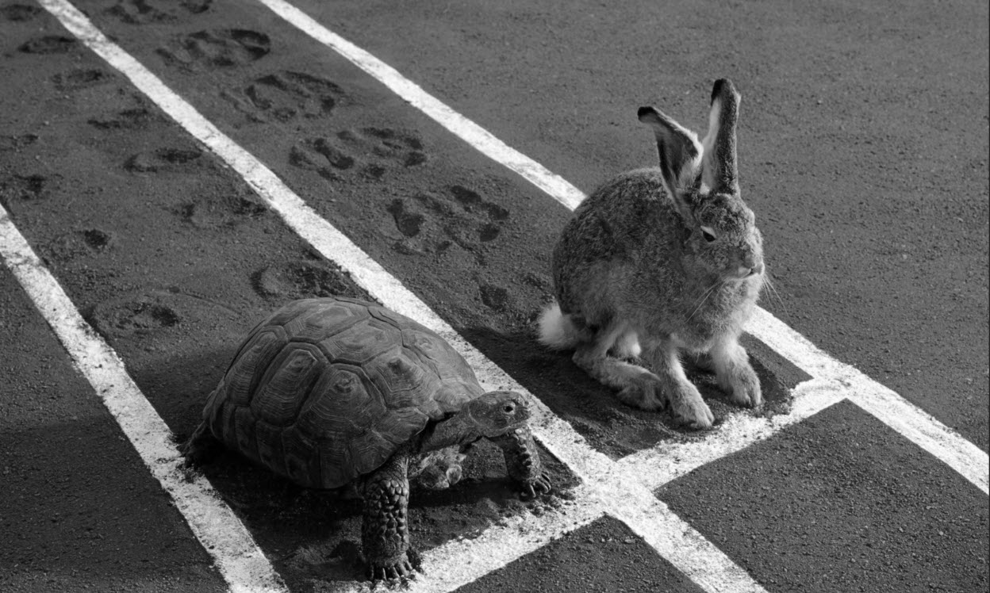
The hare, quite frankly, was a braggart. He bragged about many things, and on this occasion, he was bragging to a gathering of forest animals about how fast he could run.
“I am faster than any of you,” he said with a sneer. The animals rolled their eyes as if to say, “Here he goes again.” And indeed, the hare fully intended to press his case until he got a rise out of one of his fellows. “Ha, ha, ha. Ho, ho, ho. I am the best, yes, I am the best. Why doesn’t someone challenge me?” the hare said. “What are you … scared?”
The animals were not scared but they sure were tired of listening to this hare. Still no one said anything. Finally, the tortoise said simply, “I am not scared. I will challenge you.” The animals turned to the tortoise in amazement. He was not exactly famous for his speed.
The hare was very amused. “This is a great joke,” he said. “Why, I could run circles around you the whole way,” he said, cracking up again. “Right, right,” said the tortoise. “Shall we begin?”
The hare agreed so the course was fixed and the start was made. The hare was an exceptional runner and he darted out of sight. He ran a few laps and then, to insult the tortoise, he lay down to take a nap. It was a warm afternoon and the hare fell into a deep sleep.
The tortoise was very much awake. He made tiny, painstaking steps, plodding in the sun without complaint. When the hare suddenly awoke from his nap, the tortoise had just crossed the finish line. The hare broke into a frenzied sprint, but it was too late.

Questions:
This story highlights the commitment that the tortoise has shown, as well as other attributes such as bravery, confidence and endurance. Think about the commitment demonstrated by the tortoise in this story as you answer the following questions.
1 – How has the tortoise in this story shown commitment?
_______________________________________________________________________________________________
_______________________________________________________________________________________________
_______________________________________________________________________________________________
_______________________________________________________________________________________________

2 - What does this story teach us about talent and hard work?
_______________________________________________________________________________________________
_______________________________________________________________________________________________
_______________________________________________________________________________________________
_______________________________________________________________________________________________
_______________________________________________________________________________________________

3 – How have you shown commitment in your life?
_______________________________________________________________________________________________
_______________________________________________________________________________________________
_______________________________________________________________________________________________
_______________________________________________________________________________________________
_______________________________________________________________________________________________

3 – What are some things that you’d like to commit to in the future?
_______________________________________________________________________________________________
_______________________________________________________________________________________________
_______________________________________________________________________________________________
_______________________________________________________________________________________________
_______________________________________________________________________________________________

4 – Demonstrating commitment is not always easy. Perhaps the tortoise was intimidated by the hare’s bragging and by the speed he demonstrated when he opened up a big lead early in the race. What barriers might you need to overcome to show commitment in the areas you have identified above? How can you overcome these barriers?
_______________________________________________________________________________________________
_______________________________________________________________________________________________
_______________________________________________________________________________________________
_______________________________________________________________________________________________
_______________________________________________________________________________________________
_______________________________________________________________________________________________

NELSON MANDELA
Location: Student Booklet, pages 11-12.
Purpose: To develop the idea of commitment being an ongoing process and one which can have a positive impact on society.
Teaching notes: Read through the short biographical text with the students. Discuss students reaction to the text and how they think it relates to the concept of commitment.

Question 1 relates to student responses to the text. The second question asks students to reflect on their position within various communities and the extent to which their commitments can have implications broader than their own personal interests. This can be supported by discussions related to the community values of The Run Beyond Project and the fact that people rely on each others’ commitments. This includes teachers, students, Run Beyond Board Members, Race Directors, sponsors and others.

NELSON MANDELA
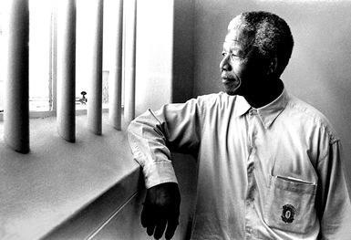
Nelson Mandela was a civil rights leader in South Africa. He fought against the white government and its system of apartheid. Apartheid means that non-white citizens did not have equal rights and were treated very badly. Although Nelson Mandela spent a lot of his life in prison for his protests, he became a symbol for his people and he eventually became President of South Africa.
Nelson Mandela was a leader in the African National Congress (ANC). At first he wanted protesters to use non-violence. However, he started to think this would not work, so he started an organisation entitled Umkhonto we Sizwe, or “Spear of the Nation”, which planned bombings such as 1961’s attacks on power stations and government buildings in Port Elizabeth, Durban and Johannesburg. The South African government called Nelson Mandela a terrorist and sent him to prison.
Mandela spent 27 years in prison. This brought worldwide attention to the problem of apartheid. The government finally released Mandela from prison in 1990. Once released from prison, Nelson continued to fight to end apartheid. In 1994 he won the election and became president of South Africa, with the official laws ending in 1991.
Adapted from http://www.ducksters.com/biography/nelson_mandela.php
Nelson Mandela’s Quote on Commitment
I have walked that long road to freedom. I have tried not to falter; I have made missteps along the way. But I have discovered the secret that after climbing a great hill, one only finds that there are many more hills to climb. I have taken a moment here to rest, to steal a view of the glorious vista that surrounds me, to look back on the distance I have come. But I can rest only for a moment, for with freedom comes responsibilities, and I dare not linger, for my long walk is not yet ended. -- Nelson Mandela

Questions:
1 - How did Nelson Mandela demonstrate commitment? What can we learn from this?
__________________________________________________________________________________________
__________________________________________________________________________________________
__________________________________________________________________________________________
__________________________________________________________________________________________
__________________________________________________________________________________________
__________________________________________________________________________________________
__________________________________________________________________________________________
__________________________________________________________________________________________
__________________________________________________________________________________________

2 - Consider the quote at the bottom of the previous page. Mandela says “But I can rest only for a moment, for with freedom comes responsibilities, and I dare not linger, for my long walk is not yet ended.” Do you agree that with freedom comes responsibilities? In what ways do you have responsibilities to make various commitments?
__________________________________________________________________________________________
__________________________________________________________________________________________
__________________________________________________________________________________________
__________________________________________________________________________________________
__________________________________________________________________________________________
__________________________________________________________________________________________
__________________________________________________________________________________________
__________________________________________________________________________________________
__________________________________________________________________________________________

THE MELBOURNE TEENAGER GOING TO SCHOOL WHILE LIVING UNDER A BRIDGE (AND ABRIDGED VERSION) STUDENT ACTIVITIES
Location: Original Version - Student Handbook, pages 13-15
Abridged Version - Student Handbook, pages 16-17
Questions - Student Handbook, page 18
Additional resources:
http://www.therunbeyondproject.com/teaching_docs/resilience.pdf
OR
http://www.therunbeyondproject.com/teaching_docs/resilience.ppt
Purpose: To develop an understanding of resilience and how it can be applied in the context of The Run Beyond Project and more broadly in other areas of one’s life.
Teaching notes:
Prior to reading Alicia’s story, introduce the concept of resilience with the students using the pdf or PowerPoint above.
Read through the Alicia’s story with the students. Discuss concept of resilience and discuss why this is important within the context of the Goal Race, and how the concept can be applied ‘beyond’ the field of running.
Potential discussion points include asking students to identify other people (famous or people they know personally) who have demonstrated resilience. How was this quality helped these people?

Question 1 should be relatively straightforward for the students after going through the resilience PowerPoint or PDF and discussing the concept further in relation to the article about Alicia.

Question 2 can involve a discussion or re-reading of the text. Another suggestion is to read through the questions with the students, before reading the text, and asking them to highlight examples of Alicia’s resilience as they go.

Questions 3 and 4 look at applying the skill of resilience within the context of the Goal Race, in the case of question 3, and beyond this, in the case of question 4, using Alicia’s case as a springboard for further exploration of the concept.

Instructions: Read the article below and answer the questions on page 18.
The Melbourne teenager going to school while living under a bridge
Aisha Dow
Published: June 3 2015 - 12:15AM
Source: http://www.theage.com.au/victoria/the-melbourne-teenager-going-to-school-while-living-under-a-bridge-20150601-ghe4at.html
A suit bag is an odd thing to find in a homeless camp. But its owner is planning to go places.
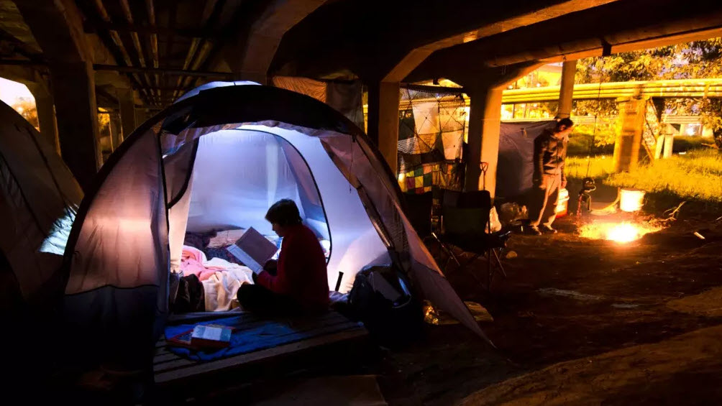
It hangs here in the gloom cast by a small road bridge in inner-Melbourne, where a collection of flimsy tents, a dusty mattress and a camp stove are tucked away from public view.
The white drycleaner suit bag has been lashed to a concrete beam, where it sways above the dirt floor of the squat.
It is a surprising item that says something important about the aspirations of its owner.
She's been homeless in Melbourne for almost three years, but Alicia*, 19, is studying Year 11 at RMIT University.
Not many high school students start their day at a soup kitchen. But Alicia does.
She and her boyfriend walk to a North Melbourne drop-in centre for a warm breakfast before Alicia travels into the city. She attends classes Monday to Friday at RMIT's Melbourne campus, which offers Year 11 and 12 subjects.
Unlike a traditional high school, the students who attend RMIT do not have to take part in extracurricular activities or subject themselves to long, boring assemblies with the school principal.
Most of Alicia's school work is done in class, otherwise she will go to the State Library, Youth Projects homeless service, or study alongside her tent by lamplight. Her favourite subject is legal studies and she dreams of becoming a criminologist.
"I'm not one of those people who want to be married and have kids," Alicia says. "I want to start my career first."
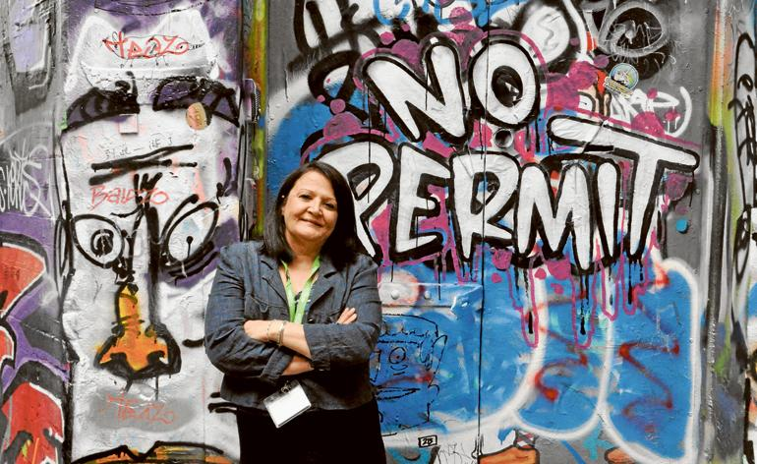
In recent months she has been taken under the wing of Youth Projects chair Melanie Raymond, who was shocked to find Alicia in a drop-in centre doing homework among a throng of homeless men one afternoon.
"All she asked me for that night was a couple of highlighter pens, some folders and some paperclips," Ms Raymond said.
Since that first meeting, Alicia has been helping Youth Projects establish a new youth advisory group. She also attended a women's leadership camp while living on the streets. Ms Raymond says Alicia is a young woman with "huge potential".
"If you can stick at Year 11 (which is tough for most teenagers) from under a bridge, you're as tough as nails. I would employ anyone that has overcome that adversity," she said.
But as the days march on and Alicia remains living under a bridge, she is statistically more likely to stay homeless and lose grip of her dream of a professional life. The rough-sleeping student is currently surviving on a budget of $360 a fortnight, shared between four homeless people. "I always run out," she says. "I'm dead broke now."
Unbelievably, Ms Raymond said Alicia was recently told she was ineligible for a grant for financial assistance for "at-risk youth" to finish their education because she was already homeless.
Over the last seven months, Alicia and her friends have been camping in overgrown and tucked-away corners of the city. They constructed a shanty among giant weeds and a pair of willow trees on the edge of an unused industrial paddock in North Melbourne. Using liquid nails, they built their own "lounge room" and were in the process of adding a second bedroom to the hut when the site's owner discovered them.
They were literally chased away, threatened with trespass and Alicia was forced to leave her school books behind.
That day, they walked for hours until they finally found a new place to stay – a concrete bridge shelter alongside a creek a short distance from the CBD.
Protected on both sides by long grass and bushes, it is prime squatting real estate. Only dog walkers and the occasional graffiti tagger ever venture down the overgrown riverbank.
Sometimes Alicia and her boyfriend set up their camp chairs in the gentle winter sun and watch the ducks paddle along the slow brown creek.
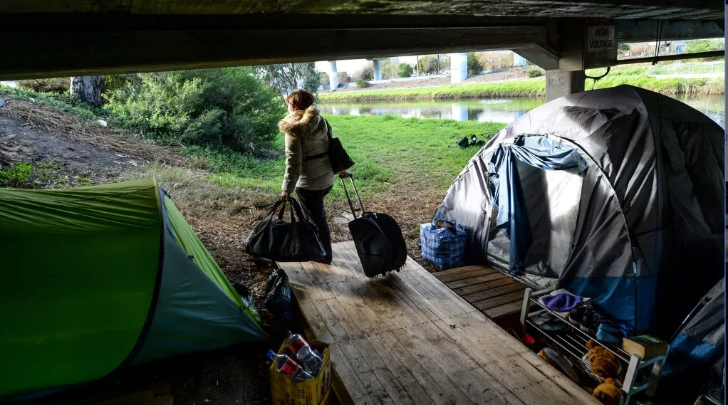
It is at this almost-scenic location that it becomes easier to understand something about Alicia that will probably frustrate some who read this story.
In the past year, she turned down a number of offers to stay in youth refuges or share houses.
She says her previous experience of living in shelters with other young people escaping homelessness were so traumatic, she would rather live on the streets until she is able to get a unit of her own.
"I know it probably sounds pig-headed because it is a house," Alicia says. "But I have been to a youth refuge and it was horrible. You got stuff taken. There were drug and alcohol issues. It's not like here where you can come home and relax. There are always police at the door."
Alicia's current camp under the bridge is more of a home than the place she grew up, with parents who were not poor but refused to buy her new school shoes, even when the old ones had so many holes they had to be patched with silver duct tape.
She was just eight or nine years old when she first spent nights sleeping on the streets (often in a cabin of an old boat moored at a marina) seeking a temporary refuge from her violent family home.
And her tent is cosier than the peeling weatherboard cottage she stayed in with seven others in Brunswick, which was infested with rats and had an abandoned methamphetamine laboratory out the back.
And it is a world away from Southern Cross Station, where Alicia resided for more than a year when she first moved to Melbourne. She spent days flicking through the free newspapers discarded around the terminal, but could not stave off the crippling boredom.
"Pretty much every day was the same day. It was like there was no tomorrow," she says.
At night she would sleep at the station in the waiting room with the padded seats and heating, before a security guard would come and close the room after trains stopped running. She would then move to the bus terminal, where the seats were metal and the room often cold. Sometimes, the security guards would tell her "this train you're waiting for is never coming".
While living homeless, Alicia usually wears track pants or jeans and a woolly jumper. She wears little makeup and her brown hair is cut short, just below the ears, adding to the impression she is a bit of a tomboy.
But appearances can be deceiving.
The black two-piece suit that hangs in Alicia's riverside camp was donated to her about two months ago to use when she was invited to go on a business tour of the Melbourne Magistrates' Court – a day she was repeatedly mistaken for a lawyer.
Alicia may be no "girly girl", but she says she loves being able to get dolled up in her suit, heels and some costume jewellery.
It is the only time she does not feel homeless.
"It's an incredible difference. The way you're looked at is different," she says. "You feel so much better."
*Name has been changed at request of the subject.
(Questions on page 18)

Instructions: Read the article below and answer the questions on the following page.
The Melbourne teenager going to school while living under a bridge (Abridged version)
Adapted from an article by Aisha Dow
Published: June 3 2015 - 12:15AM
Source: http://www.theage.com.au/victoria/the-melbourne-teenager-going-to-school-while-living-under-a-bridge-20150601-ghe4at.html
Alicia*, 19, has been homeless in Melbourne for almost 3 years, but is studying Year 11 at RMIT University.
She and her boyfriend walk to a North-Melbourne drop-in centre for a warm breakfast before Alicia travels into the city. She attends classes Monday to Friday at RMIT’s Melbourne campus, which offers Year 11 and 12 subjects.
Whatever work Alicia doesn’t finish in class, she does at the State Library, Youth Projects homeless service, or in her tent at night, where she has a lamp. Her favourite subject is Legal Studies, and she dreams of becoming a criminologist.
“I’m not one of those people who want to be married and have kids,” Alicia says. “I want to start my career first.”
She has recently been helped by Melanie Raymond from the Youth Projects organisation, who found her doing homework among a group of homeless men one afternoon.
Since their first meeting, Alicia has worked in a leadership role with Youth Projects and has attended a women’s leadership camp while living on the streets. Ms Raymond says Alicia is a young woman with “huge potential”.
“If you can stick at Year 11 (which is tough for most teenagers) from under a bridge, you’re as tough as nails. I would employ anyone that has overcome that adversity,” she said.
Times are very difficult for Alicia. She is currently surviving on a budget of $360 a fortnight, shared between four homeless people. “I’m dead broke now,” she says.
She has set up her tent in a few locations and had to move when she’s been kicked out by people who owned the land. Currently she lives under a bridge, alongside a creek a short distance from the city. Sometimes Alicia and her boyfriend set up their camp chairs in the gentle winter sun and watch the ducks paddle along the slow brown creek.
In the past year, Alicia has turned down offers to stay in youth refuges or share houses because of previous traumatic experiences in these. “I have been to a youth refuge and it was horrible. You got stuff taken. There were drug and alcohol issues. It’s not like here where you can come home and relax. There are always police at the door.”
Alicia was just eight or nine years old when she first spent nights on the streets, seeking refuge from her violent family home.
She has also shared a small cottage with seven others, but this was infested with rats, so she prefers her tent. It is also more convenient than when she tried living at a station when she was often moved on in the middle of the night after the last trains, when the waiting room closed.
She often wears track pants or jeans and a woolly jumper. She wears little makeup and her brown hair is cut short, adding to the impression that she is a bit of a tomboy.
But appearances can be deceiving.
She had a black suit donated to her recently which she hangs up under the bridge, next to her tent. She wore this when she was invited to go on a business tour of the Melbourne Magistrates’ Court - a day she was repeatedly mistaken for a lawyer.
“It’s an incredible difference. The way you’re looked at is different,” she says. “You feel so much better.”
*Name has been changed at request of the subject.

Questions:
Answer the below questions about resilience.
1 – Explain in your words what is meant by the term resilience.
_______________________________________________________________________________________________
_______________________________________________________________________________________________
_______________________________________________________________________________________________

2 – How did Alicia demonstrate resilience?
_______________________________________________________________________________________________
_______________________________________________________________________________________________
_______________________________________________________________________________________________
_______________________________________________________________________________________________
_______________________________________________________________________________________________

3 – How might we need to demonstrate resilience on the way to our Goal Race?
_______________________________________________________________________________________________
_______________________________________________________________________________________________
_______________________________________________________________________________________________
_______________________________________________________________________________________________
_______________________________________________________________________________________________
4 – What can Alicia’s story teach people about how to react to obstacles in life?
_______________________________________________________________________________________________
_______________________________________________________________________________________________
_______________________________________________________________________________________________
_______________________________________________________________________________________________
_______________________________________________________________________________________________
RESILIENCE & SELF WORTH STUDENT ACTIVITIES
Location: Student Booklet, pages 19-20
Purpose: To develop an appreciation in students that self-awareness of their own positive attributes can equip them to more effectively overcome adversity.
Teaching notes:

Commence with a discussion about the positive ramifications of appreciating our own self-worth, in terms of being better equipped to handle adversity. Also generate discussion about flow on effects in terms of our capacity to interact with our peers and community more effectively when we have a greater sense of self worth.

Question one simply asks students to identify attributes by highlighting them. Have a dictionary or device handy to allow students to search for words which they are not familiar with. Provide assistance with definitions as required.
Question 2 is an extension of this.

The third question requires more self-reflection from students and may require prompting and guiding questions from teachers. It may be useful to prompt with questions which relate to behaviours you have observed within the course of The Run Beyond Project thus far. Eg: “Tom, you’ve been the first one changed and ready for training every single week. Which trait do you think that demonstrates? ….I can think of one starting with R…” or “Jessica, you’re always helping out with warm up exercises and you’re constantly encouraging everyone else in the team. Is that the behaviour of a follower or a ….?”

RESILIENCE AND SELF WORTH
Those people who cope well with problems and bounce back are said to be resilient. Resilient people value themselves. They have a good sense of self-worth. In order to help you appreciate your own worth, have a look at the following positive attributes. Think about which ones apply to you.

Positive Character Traits
Active | Adventurous | Affectionate | Ambitious | Attentive | Bold
Brainy | Brave | Calm | Careful | Charming | Cheerful
Confident | Considerate | Cooperative | Courageous | Curious | Daring
Decisive | Dependable | Determined | Dutiful | Eager | Easygoing
Efficient | Encouraging | Energetic | Excited | Fair | Faithful
Fearless | Fierce | Funny | Gentle | Graceful | Grateful
Happy | Healthy | Helpful | Honest | Hopeful | Humorous
Imaginative | Independent | Industrious | Intelligent | Kind | Leader
Lively | Loving | Loyal | Mature | Obedient | Peaceful
Pleasant | Polite | Positive | Precise | Proud | Quick
Quiet | Reliable | Responsible | Satisfied | Serious | Smart
Thankful | Thoughtful | Tolerant | Trusting | Trustworthy | Warm
Wise

Activities:
1 – Put a tick next to, or highlight, any words you think apply to you.
2 – For any words whose meaning you are not sure of, ask your teacher, or use a search engine (such as Google) or the dictionary to find a synonym which you do know. Write these words and their meanings or synonyms in the space below.
_______________________________________________________________________________________________
_______________________________________________________________________________________________
_______________________________________________________________________________________________
_______________________________________________________________________________________________
_______________________________________________________________________________________________
_______________________________________________________________________________________________
_______________________________________________________________________________________________

3 – Write down 3 words which most apply to you. In the space below, explain how you demonstrate these qualities.
Word 1 _______________________________________________________________________________________________
_______________________________________________________________________________________________
_______________________________________________________________________________________________
_______________________________________________________________________________________________
_______________________________________________________________________________________________
_______________________________________________________________________________________________
_______________________________________________________________________________________________

Word 2 _______________________________________________________________________________________________
_______________________________________________________________________________________________
_______________________________________________________________________________________________
_______________________________________________________________________________________________
_______________________________________________________________________________________________
_______________________________________________________________________________________________
_______________________________________________________________________________________________

Word 3 _______________________________________________________________________________________________
_______________________________________________________________________________________________
_______________________________________________________________________________________________
_______________________________________________________________________________________________
_______________________________________________________________________________________________
_______________________________________________________________________________________________
_______________________________________________________________________________________________

RESILIENCE & BELONGING STUDENT ACTIVITIES
Location: Student Booklet, pages 21-22
Purpose: To develop an appreciation in students of the connection between resilience and belonging to teams, groups and communities.
Teaching notes:

Commence with a discussion about the positive ramifications of belonging and appreciating our peers and team mates, and how this has positive implications for our resilience and theirs.

Question one simply asks students to identify attributes of their teammates by highlighting them. Have a dictionary or device handy to allow students to search for words which they are not familiar with. Provide assistance with definitions as required.
Question 2 is an extension of this.

The third question requires more analysis by students of their teammates’ qualities and capabilities. This may require some teacher assistance and prompting, which is often best provided out of earshot of the team mate in question. Eg: “Well I saw Jessica encouraging you and all the others when you finished your laps last week. She was cheering and congratulating all of you. She often volunteers to demonstrate the stretches when we’re warming up too. What quality do you think that demonstrates?”

RESILIENCE & BELONGING
Those people who cope well with problems and bounce back are said to be resilient. Resilient people have good relationships with others and feel part of a community or group. They have a good sense of belonging. In order to help you develop a sense of belonging, have a look at the following positive attributes. Think about which ones apply to your teammates.

Positive Character Traits
Active | Adventurous | Affectionate | Ambitious | Attentive | Bold
Brainy | Brave | Calm | Careful | Charming | Cheerful
Confident | Considerate | Cooperative | Courageous | Curious | Daring
Decisive | Dependable | Determined | Dutiful | Eager | Easygoing
Efficient | Encouraging | Energetic | Excited | Fair | Faithful
Fearless | Fierce | Funny | Gentle | Graceful | Grateful
Happy | Healthy | Helpful | Honest | Hopeful | Humorous
Imaginative | Independent | Industrious | Intelligent | Kind | Leader
Lively | Loving | Loyal | Mature | Obedient | Peaceful
Pleasant | Polite | Positive | Precise | Proud | Quick
Quiet | Reliable | Responsible | Satisfied | Serious | Smart
Thankful | Thoughtful | Tolerant | Trusting | Trustworthy | Warm
Wise

Activities:
1 – Put a tick next to, or highlight, any words you think apply to your teammates. Put the initials of each team mate in the appropriate box, so it is clear which characteristic is related to which person.
2 – For any words whose meaning you are not sure of, ask your teacher, or use a search engine (such as Google) or the dictionary to find a synonym which you do know. Write these words and their meanings or synonyms in the space below.
_______________________________________________________________________________________________
_______________________________________________________________________________________________
_______________________________________________________________________________________________
_______________________________________________________________________________________________
_______________________________________________________________________________________________
_______________________________________________________________________________________________

3 – Write one word which most applies to each teammate. In the space below, explain how this person demonstrates these qualities.
Teammate 1 (name: ____________________________ )
_______________________________________________________________________________________________
_______________________________________________________________________________________________
_______________________________________________________________________________________________
_______________________________________________________________________________________________
_______________________________________________________________________________________________
Teammate 2 (name: ____________________________ )
_______________________________________________________________________________________________
_______________________________________________________________________________________________
_______________________________________________________________________________________________
_______________________________________________________________________________________________
_______________________________________________________________________________________________
Teammate 3 (name: ____________________________ )
_______________________________________________________________________________________________
_______________________________________________________________________________________________
_______________________________________________________________________________________________
_______________________________________________________________________________________________
_______________________________________________________________________________________________
Teammate 4 (name: ____________________________ )
_______________________________________________________________________________________________
_______________________________________________________________________________________________
_______________________________________________________________________________________________
_______________________________________________________________________________________________
_______________________________________________________________________________________________
Teammate 5 (name: ____________________________ )
_______________________________________________________________________________________________
_______________________________________________________________________________________________
_______________________________________________________________________________________________
_______________________________________________________________________________________________
_______________________________________________________________________________________________

GROWTH MINDSET STUDENT ACTIVITIES
Location: Student Booklet, pages 23-24
Additional resources:
http://therunbeyondproject.com/teaching_docs/growth_mindset.pdf
OR
http://therunbeyondproject.com/teaching_docs/growth_mindset.ppt
Purpose: To introduce students to the idea of a Growth Mindset, and promote the idea that this mentality can help with the application of goal-setting, commitment and resilience skills acquired previously.
Teaching notes: The first five questions relate to how students have demonstrated the skills outlined in the PDF. Perhaps prompt students with examples of how they’ve demonstrated these within the course of the project and offer some suggestions as to areas beyond the scope of the project in which they may have demonstrated these skills. Eg: “We’ve all embraced the challenge of our Goal Race. We demonstrate this by turning up each week and working towards it. What other changes have you all embraced? Think about school work, sporting teams, finding a job, resolving conflicts, etc.”

The final question relates the Growth Mindset skills to Goal Setting, Commitment and Resilience. This may be best brainstormed as a group.

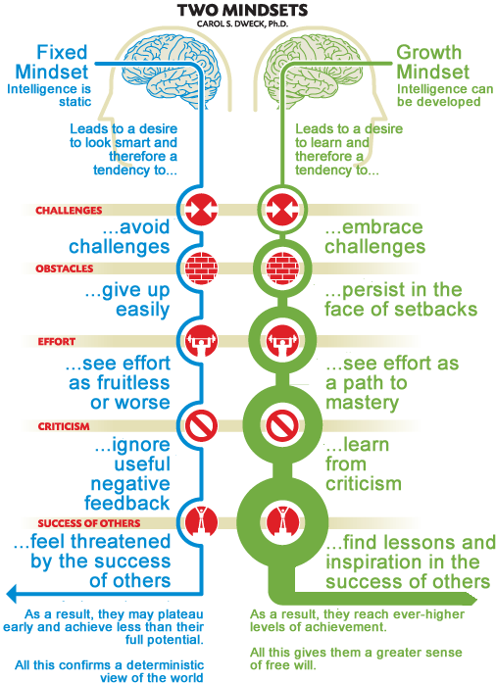
A Growth Mindset refers to the belief that talents can be improved by hard work and using feedback from others. It is opposed to a “Fixed Mindset”, which is the belief that our talents and abilities are fixed, and not changeable.

Activity:
Identify how you have demonstrated some of the various characteristics of a Growth Mindset.
1 - People with a growth mindset embrace challenges. I have embraced challenges by…
__________________________________________
__________________________________________
__________________________________________
__________________________________________
__________________________________________
__________________________________________
__________________________________________
__________________________________________
__________________________________________
__________________________________________
__________________________________________

2 - People with a growth mindset persist in the face of obstacles. I have persisted in the face of obstacles by…
_______________________________________________________________________________________________
_______________________________________________________________________________________________
_______________________________________________________________________________________________
_______________________________________________________________________________________________
_______________________________________________________________________________________________

3 - People with a growth mindset see effort as the path to mastery. I put in effort in attempt to master new skills when I…
_______________________________________________________________________________________________
_______________________________________________________________________________________________
_______________________________________________________________________________________________
_______________________________________________________________________________________________
_______________________________________________________________________________________________

4 - People with a growth mindset learn from criticism. I learnt from criticism when I…
_______________________________________________________________________________________________
_______________________________________________________________________________________________
_______________________________________________________________________________________________
_______________________________________________________________________________________________
_______________________________________________________________________________________________

5 - People with a growth mindset find lessons and inspiration in the success of others. I find lessons and inspiration in the success of others when I…
_______________________________________________________________________________________________
_______________________________________________________________________________________________
_______________________________________________________________________________________________
_______________________________________________________________________________________________
_______________________________________________________________________________________________

6 - Previously we’ve learnt about goal-setting, commitment and resilience. How do these relate to the 5 elements of the Growth Mindset which have been examined in the previous questions?
_______________________________________________________________________________________________
_______________________________________________________________________________________________
_______________________________________________________________________________________________
_______________________________________________________________________________________________
_______________________________________________________________________________________________
_______________________________________________________________________________________________
_______________________________________________________________________________________________
_______________________________________________________________________________________________
_______________________________________________________________________________________________
SUCCESS STUDENT ACTIVITIES
Location: Student Booklet, pages 25-26.
Additional resources:
http://therunbeyondproject.com/teaching_docs/success.pdf
OR
http://therunbeyondproject.com/teaching_docs/success.ppt
Purpose: To reinforce an understanding of the process of success being a prolonged one that involves goal-setting, commitment and resilience, and one which can be largely unappreciated by outside observers, but nevertheless rewarding.
Teaching notes: Generate discussion on the rewarding nature of success as the presentation is completed. This activity offers another opportunity to remind students that the goal of The Run Beyond Project is to promote success in all fields of endeavour beyond the completion of the project.

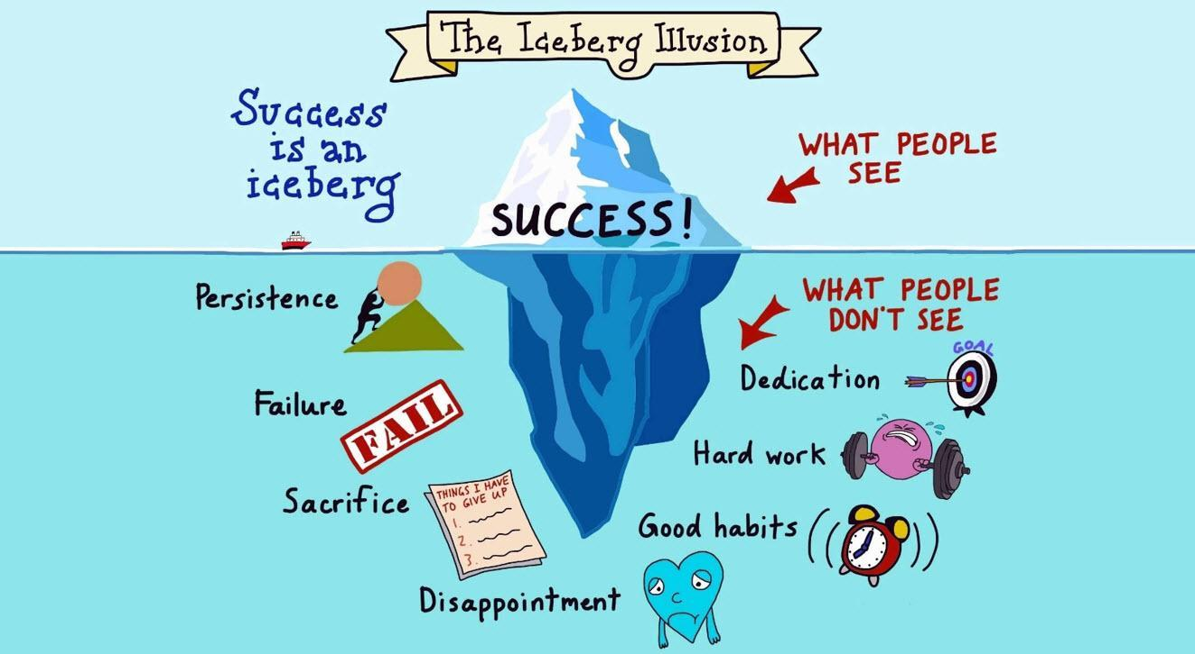
Watch the presentation on Success.
Activity:
Write a few paragraphs that outline how you would like to see yourself being successful in the future. Write about what people will see and all of the things they won’t see. Write about how you’ll have to be persistent, overcome failure, make sacrifices, deal with disappointment, dedicate yourself, work hard and form good habits.
_______________________________________________________________________________________________
_______________________________________________________________________________________________
_______________________________________________________________________________________________
_______________________________________________________________________________________________
_______________________________________________________________________________________________
_______________________________________________________________________________________________
_______________________________________________________________________________________________
_______________________________________________________________________________________________
_______________________________________________________________________________________________
_______________________________________________________________________________________________
_______________________________________________________________________________________________
_______________________________________________________________________________________________
_______________________________________________________________________________________________
_______________________________________________________________________________________________
_______________________________________________________________________________________________
_______________________________________________________________________________________________
_______________________________________________________________________________________________
_______________________________________________________________________________________________
_______________________________________________________________________________________________
_______________________________________________________________________________________________
_______________________________________________________________________________________________
_______________________________________________________________________________________________
_______________________________________________________________________________________________
_______________________________________________________________________________________________
_______________________________________________________________________________________________
_______________________________________________________________________________________________
_______________________________________________________________________________________________
_______________________________________________________________________________________________
_______________________________________________________________________________________________
_______________________________________________________________________________________________
_______________________________________________________________________________________________
_______________________________________________________________________________________________
_______________________________________________________________________________________________
_______________________________________________________________________________________________
_______________________________________________________________________________________________
_______________________________________________________________________________________________
_______________________________________________________________________________________________
_______________________________________________________________________________________________
_______________________________________________________________________________________________
_______________________________________________________________________________________________
_______________________________________________________________________________________________
_______________________________________________________________________________________________
COMMUNITY STUDENT ACTIVITIES
Location: Student Booklet, pages 27-28.
Additional resources:
http://therunbeyondproject.com/teaching_docs/community.pdf
OR
http://therunbeyondproject.com/teaching_docs/community.ppt
Purpose: To foster awareness of the importance of communities and belonging, how communities help individuals pursuing their individual goals and how individuals can contribute to the communities to which they belong.
Teaching notes:
Question 1 asks students to identify communities they belong to and how those communities have helped them. Use The Running Community as an example and encourage the students to consider other communities to which they belong.
Question 2 is designed to prompt students to consider their capacity to contribute and to use the skills learnt throughout the project to do so.
Question 3 offers a chance to put this in to practice within the context of the parkrun community, supported by you within the context of this project.

Watch the presentation on Community.
Questions:
Question 1: Write down some communities that you belong to, and how they’ve helped you.
_______________________________________________________________________________________________
_______________________________________________________________________________________________
_______________________________________________________________________________________________
_______________________________________________________________________________________________
_______________________________________________________________________________________________
_______________________________________________________________________________________________
_______________________________________________________________________________________________
Question 2: Write down some communities that you belong to, and how you’ve helped them. If you haven’t made a contribution yet, what could you do in the near future?
_______________________________________________________________________________________________
_______________________________________________________________________________________________
_______________________________________________________________________________________________
_______________________________________________________________________________________________
_______________________________________________________________________________________________
_______________________________________________________________________________________________
_______________________________________________________________________________________________
_______________________________________________________________________________________________
Question 3: Parkrun is an example of an organization that welcomes people and provides them with a sense of belonging to the running community. The Run Beyond Project encourages participants to contribute to the communities that help us. What can you do to contribute to the parkrun community?
_______________________________________________________________________________________________
_______________________________________________________________________________________________
_______________________________________________________________________________________________
_______________________________________________________________________________________________
_______________________________________________________________________________________________
_______________________________________________________________________________________________
_______________________________________________________________________________________________
_______________________________________________________________________________________________
_______________________________________________________________________________________________




























